# Coffee Sales Dashboard Data Summary



## About the dataset

The Coffee Sales Dashboard dataset provides a comprehensive overview of coffee sales across various dimensions, including time, geography, customer demographics, and product specifics. The dataset is divided into six sheets, each focusing on different aspects of the sales data.

The first sheet, "COFFEE SALES DASHBOARD.sheet_0.csv," contains monthly sales data from 2019 to 2022, categorized by coffee type (Arabica, Excelsa, Liberica, and Robusta). The sample data shows that January 2019 had significant sales across all coffee types, with Excelsa leading at 305.97 units.

The second sheet, "COFFEE SALES DASHBOARD.sheet_1.csv," summarizes sales by country, highlighting that the United States had the highest sales at 35,638.88 units, followed by Ireland and the United Kingdom.

The third sheet, "COFFEE SALES DASHBOARD.sheet_2.csv," lists the top customers by sales, with Allis Wilmore leading at 317.07 units. This sheet provides insights into customer-specific sales performance.

The fourth sheet, "COFFEE SALES DASHBOARD.sheet_3.csv," is the most detailed, containing 1,000 rows of individual order data. It includes information such as order ID, order date, customer details, product specifics, and sales figures. For example, an order on September 5, 2019, by Aloisia Allner from the United States included multiple coffee types and roast levels.

The fifth sheet, "COFFEE SALES DASHBOARD.sheet_4.csv," provides customer contact information, including email, phone number, and address. This sheet can be useful for customer relationship management and targeted marketing efforts.

The sixth sheet, "COFFEE SALES DASHBOARD.sheet_5.csv," details product-specific information, including product ID, coffee type, roast type, size, unit price, price per 100g, and profit. For instance, the product "A-L-0.2" (Arabica, Light roast, 0.2 size) has a unit price of 3.885 and a profit of 0.34965.

Overall, the dataset offers valuable insights into coffee sales trends, customer behavior, and product performance, which can be leveraged for strategic decision-making and business optimization.

## Relevant Inquiries

### Q1.What are the total sales for each coffee type (Arabica, Excelsa, Liberica, Robusta) across different years?

**Arabica Sales:**

* **2019:** 186.855
* **2020:** 47.25
* **2021:** 258.345
* **2022:** 112.695
* **Total:** 605.145

**Excelsa Sales:**

* **2019:** 305.97
* **2020:** 65.805
* **2021:** 139.625
* **2022:** 166.32
* **Total:** 677.72

**Liberica Sales:**

* **2019:** 213.16
* **2020:** 274.675
* **2021:** 279.52
* **2022:** 843.715
* **Total:** 1611.07

**Robusta Sales:**

* **2019:** 123
* **2020:** 179.22
* **2021:** 160.195
* **2022:** 146.685
* **Total:** 609.1

These totals are calculated by summing the sales for each coffee type across the years 2019 to 2022.

### Q2.How do monthly sales of each coffee type vary throughout the year?

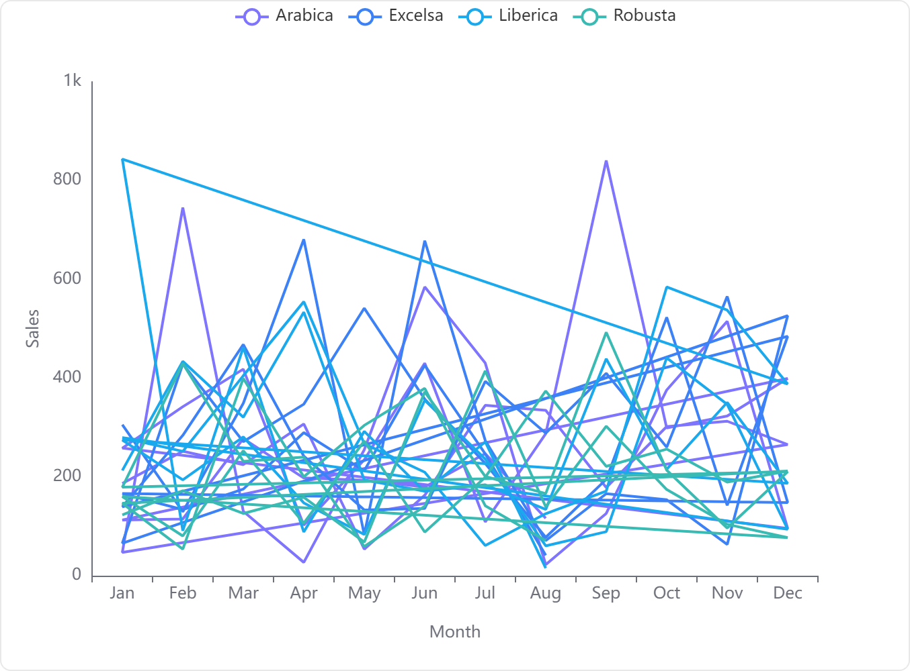

#### Overview

The line chart provided visualizes the monthly sales data for four different types of coffee: Arabica, Excelsa, Liberica, and Robusta. Each line represents the sales trajectory of one coffee type over the months from January to December.

#### Key Observations

**Arabica**: The sales of Arabica coffee show significant fluctuations throughout the year. There are peaks around April and October, suggesting higher sales during these months. The sales dip notably in May and again in November.

**Excelsa**: Excelsa coffee sales also exhibit variability, with a sharp peak in April, indicating a significant increase in sales. The sales are relatively lower at the beginning and end of the year, with another smaller peak around July.

**Liberica**: The sales pattern for Liberica coffee is somewhat erratic, with multiple peaks and troughs. The highest peak occurs in April, similar to Excelsa, and there are other notable peaks in July and September. The sales are lowest at the beginning of the year.

**Robusta**: Robusta shows a more consistent pattern compared to the other types, with fewer sharp peaks and troughs. The sales are generally moderate but show a slight increase in the middle of the year, around June and July.

#### Conclusion

**Variability in Sales**: Each coffee type shows distinct patterns of sales variability throughout the year. **Arabica** and **Excelsa** have more pronounced fluctuations, while **Robusta** tends to be more stable. **Liberica** displays the most erratic pattern, suggesting varying consumer preferences or supply issues throughout the year.

**Seasonal Peaks**: Most coffee types show sales peaks around mid-year, particularly in April, which could be linked to specific market activities or seasonal promotions.

**Sales Troughs**: Each coffee type generally experiences sales troughs at the beginning and towards the end of the year, possibly due to post-holiday slumps and pre-holiday preparations.

**Strategic Insights**: For businesses, understanding these patterns can help in planning inventory, marketing strategies, and promotions to optimize sales across different periods of the year.

### Q3.Which country has the highest total coffee sales, and how does it compare to other countries?

**Country with the Highest Total Coffee Sales:**

* **United States** with a total sales figure of **$35,638.88**. This is marked as the **Highest** in the comparison category.

**Comparison with Other Countries:**

* **United Kingdom**: Total sales of **$2,798.51**. This is significantly lower compared to the United States, categorized under **Other**.
* **Ireland**: Total sales of **$6,696.86**. Although higher than the United Kingdom, it still falls short when compared to the United States, also categorized under **Other**.

**Summary**: The United States leads by a substantial margin in coffee sales compared to the United Kingdom and Ireland. The sales in the United States are more than five times those of Ireland and nearly thirteen times those of the United Kingdom.

### Q4.Who are the top 5 customers in terms of total sales, and what are their respective sales figures?

Based on the data extracted from the 'COFFEE SALES DASHBOARD.sheet_2.csv', the top 5 customers and their respective total sales figures are as follows:

These figures represent the highest total sales recorded in the dataset for individual customers.

### Q5.Is there a correlation between the size of the coffee product and its unit price?

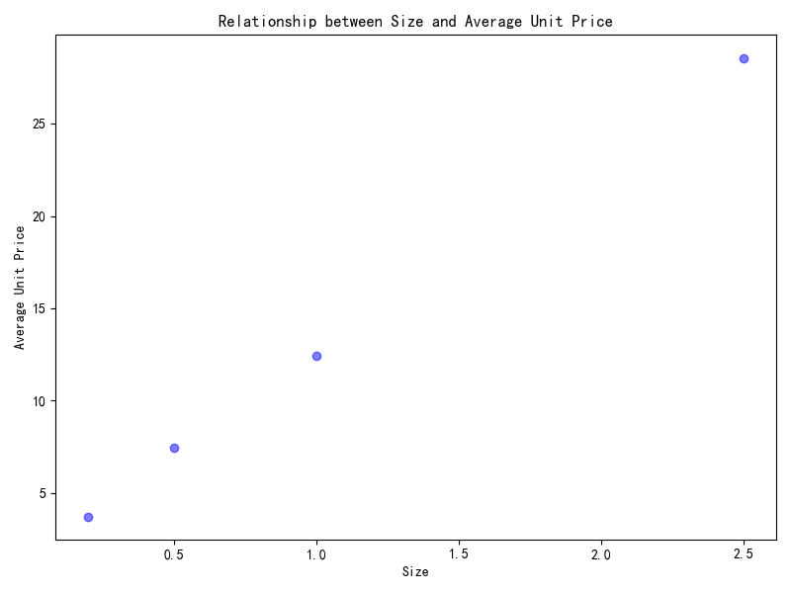**Correlation Analysis:** Based on the provided data and the scatter plot visualization, there appears to be a positive correlation between the size of the coffee product and its unit price. As the size increases, the unit price also tends to increase.

**Statistical Summary:**

* **Size**: Mean = 1.05, Standard Deviation = 1.02, Min = 0.20, Max = 2.50
* **Average Unit Price**: Mean = 13.05, Standard Deviation = 10.95, Min = 3.73, Max = 28.58

**Data Points Analysis:**

* The smallest size (0.2) has the lowest unit price (3.7275).
* The largest size (2.5) has the highest unit price (28.5775).
* Intermediate sizes (0.5 and 1.0) have intermediate prices (7.455 and 12.425 respectively).

**Visual Analysis:** The scatter plot shows a clear upward trend, indicating that as the size of the coffee product increases, the average unit price increases as well. This trend is consistent across the data points provided.

**Conclusion:** There is a positive correlation between the size of the coffee product and its unit price, suggesting that larger coffee products are generally priced higher than smaller ones. This trend is supported by both the numerical data and the visual representation in the scatter plot.

### Q6.What is the distribution of sales across different roast types (Light, Medium, Dark)?

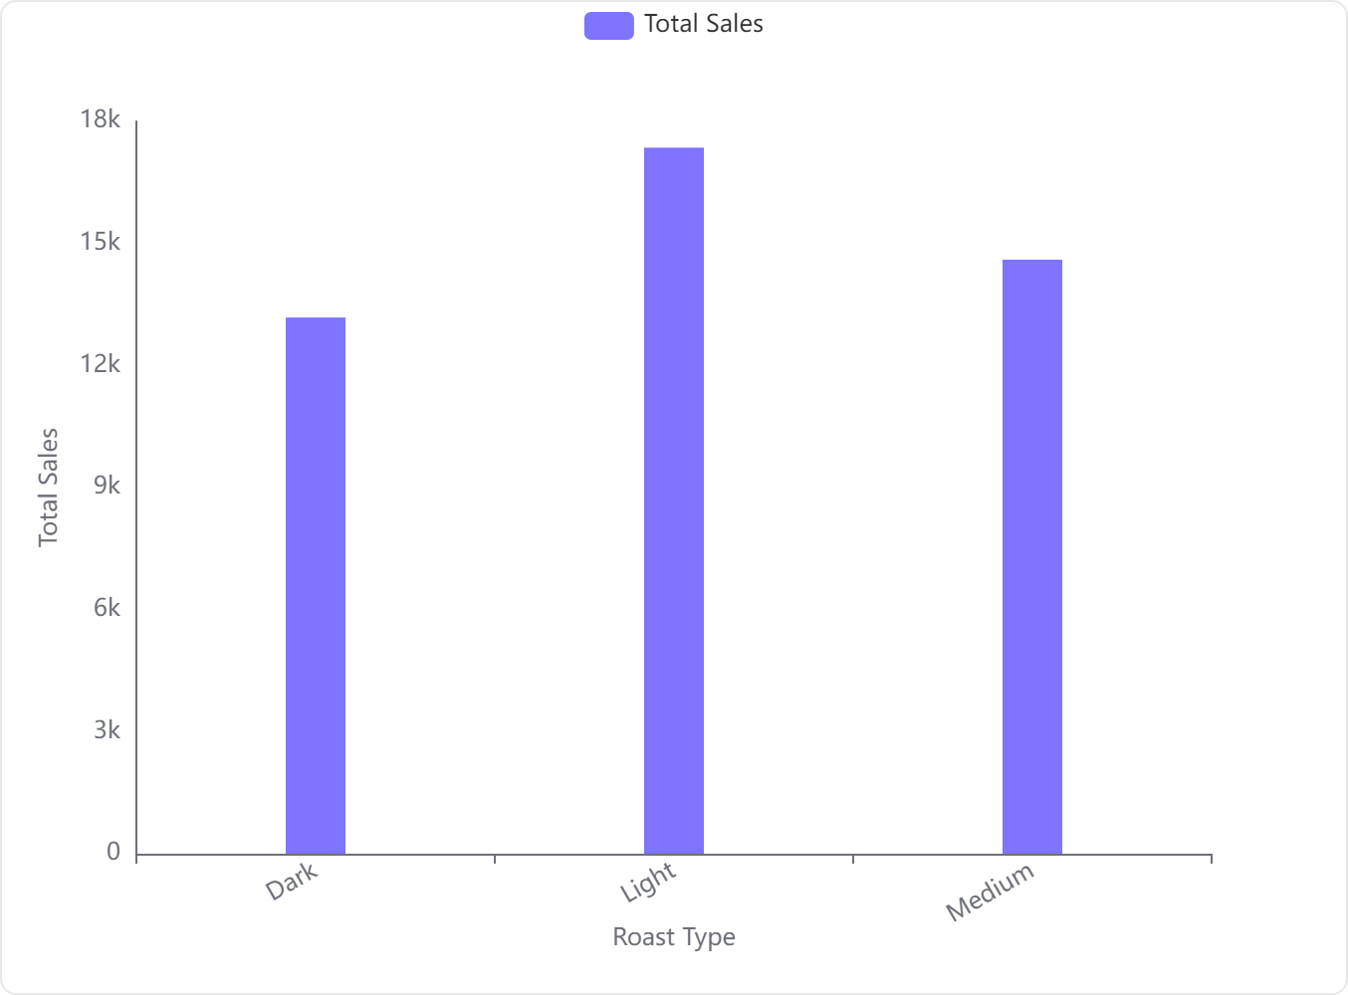

**Sales Distribution Overview:**

* **Light Roast:** The sales for Light Roast are the highest among the three categories, with a total of **$17,354.5**.
* **Medium Roast:** Medium Roast follows with sales amounting to **$14,600.5**.
* **Dark Roast:** The sales for Dark Roast are the lowest, recorded at **$13,179.3**.

**Visual Representation:**

* The provided bar chart clearly illustrates that Light Roast leads in sales, followed by Medium Roast, and Dark Roast trails behind.

**Key Insights:**

* **Light Roast** is the most popular among consumers, potentially indicating a preference for its flavor profile or other attributes.
* **Dark Roast**, despite its distinct taste, has the least sales, which could suggest a smaller target market or different consumer preferences in the dataset.

**Recommendations for Business Strategy:**

* Focus marketing efforts on promoting Light Roast to leverage its existing popularity.
* Investigate the lower sales of Dark Roast to understand consumer reservations and potentially adjust product offerings or marketing strategies accordingly.

### Q7.How does the presence of a loyalty card affect the total sales for a customer?

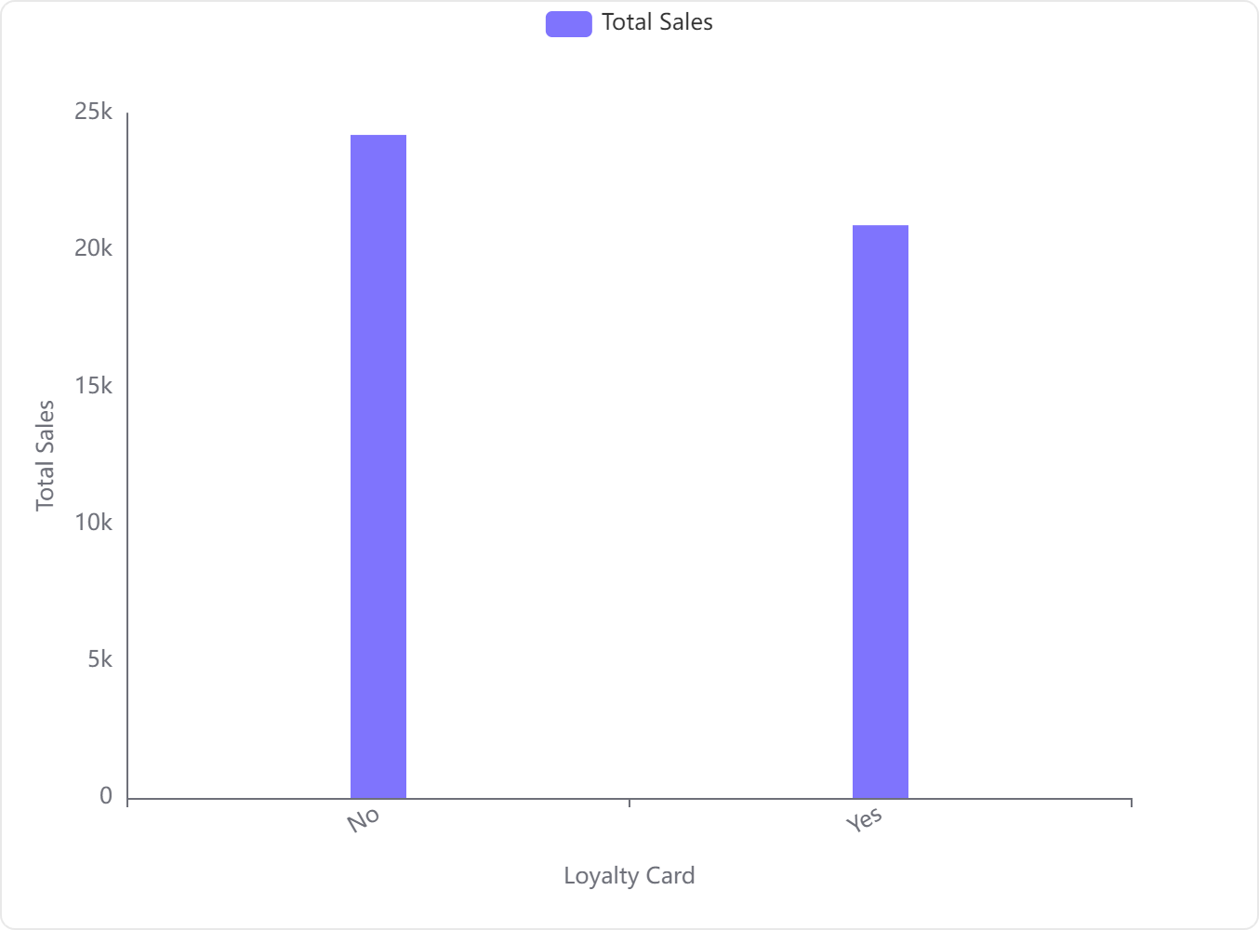

#### Key Findings:

* **Total Sales for Non-Loyalty Card Holders**: Customers without a loyalty card have a total sales amount of **$24,216.40**.
* **Total Sales for Loyalty Card Holders**: Customers with a loyalty card have a total sales amount of **$20,917.85**.

#### Analysis:

* **Higher Sales in Non-Loyalty Card Holders**: The data indicates that customers who do not have a loyalty card generate higher total sales compared to those who have a loyalty card. This is visually represented in the bar chart, where the sales for non-loyalty card holders are noticeably higher than for loyalty card holders.

#### Implications:

* **Potential Strategy Adjustments**: The current loyalty program might need reevaluation or enhancement to boost sales among loyalty card holders. This could involve better incentives or rewards that effectively encourage higher spending.

#### Conclusion:

The presence of a loyalty card is associated with lower total sales per customer. This suggests that the loyalty program may not be effectively motivating additional spending or attracting the higher spending customer segment. Further analysis and possibly a redesign of the loyalty incentives could be beneficial to align the program with increased sales objectives.

### Q8.What are the most common order quantities for different coffee types?

Based on the analysis of the 'Quantity' and 'Coffee Type' columns from the dataset, here are the findings regarding the most common order quantities for different types of coffee:

* **Ara Coffee**: The most common order quantity is **6** with a frequency of **53** orders.
* **Excelsa (Exc) Coffee**: The most common order quantity is **2** with a frequency of **54** orders.
* **Liberica (Lib) Coffee**: The most common order quantity is also **2**, observed in **51** orders.
* **Robusta (Rob) Coffee**: The most common order quantity is **5**, with **48** orders recorded.

**Summary**: The data indicates that the most frequent order quantity varies significantly among different coffee types, with Excelsa and Liberica often ordered in smaller quantities (2 units), while Ara and Robusta are generally ordered in larger quantities (6 and 5 units, respectively).

### Q9.Are there any noticeable trends in coffee sales over the years 2019 to 2022?

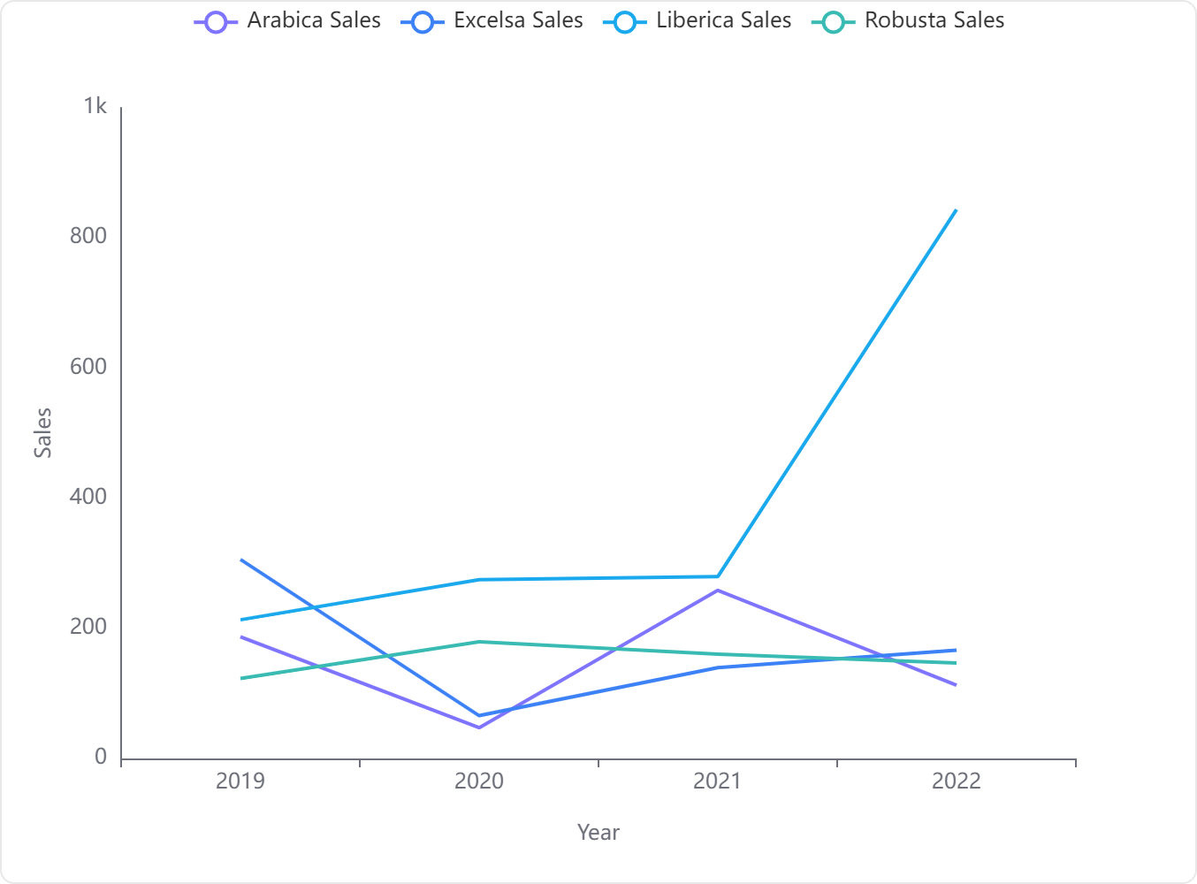

**1. Overall Trends:**

* **Liberica Sales:** There is a significant upward trend in Liberica coffee sales, especially noticeable from 2021 to 2022 where sales more than tripled.
* **Arabica Sales:** Exhibited fluctuating trends with a peak in 2021 and a sharp decline in 2020.
* **Excelsa Sales:** Started high in 2019, dropped significantly in 2020, and then showed a gradual recovery in the subsequent years.
* **Robusta Sales:** Relatively stable compared to other types, with a slight peak in 2020.

**2. Key Observations:**

* **Liberica Coffee:** The standout trend is the dramatic increase in sales of Liberica coffee in 2022, reaching 843.715 units, which is significantly higher than any other coffee type across all years.
* **Arabica Coffee:** Despite a significant drop in 2020 (47.25 units), it rebounded in 2021 (258.345 units) but again decreased in 2022 (112.695 units).
* **Excelsa Coffee:** Although starting strong in 2019 (305.97 units), it saw the lowest sales in 2020 (65.805 units) but has been recovering since.
* **Robusta Coffee:** Showed the least volatility among the coffee types with sales figures remaining in a narrower range (123.00 to 179.22 units).

**3. Implications for Future Sales:**

* **Potential Growth for Liberica:** The sharp increase in Liberica sales suggests a growing market interest or successful marketing strategies that could be further capitalized on.
* **Monitoring Arabica and Excelsa:** Given their fluctuating sales figures, these coffee types may require targeted strategies to stabilize and boost their market performance.
* **Steady Demand for Robusta:** The relative stability in Robusta sales suggests a consistent market demand, potentially making it a reliable staple in sales strategies.

**4. Recommendations:**

* **Focus on Expanding Liberica Sales:** Given its recent surge, further investment in marketing and distribution for Liberica could capitalize on its growing popularity.
* **Stabilize Arabica and Excelsa Markets:** Implement strategies to address the volatility in sales for Arabica and Excelsa, possibly through promotional campaigns or adjusting pricing strategies.
* **Maintain Robusta Supply:** Continue to support Robusta sales with consistent quality and availability to maintain its steady market presence.

These insights should guide strategic planning and operational adjustments to optimize coffee sales in the coming years.

### Q10.Which product ID has the highest profit, and what are its characteristics (coffee type, roast type, size)?

**Product ID with the Highest Profit:**

* **Product ID:** L-L-2.5

**Characteristics of the Product:**

* **Coffee Type:** Lib
* **Roast Type:** L
* **Size:** 2.5 liters
* **Profit:** $4.74